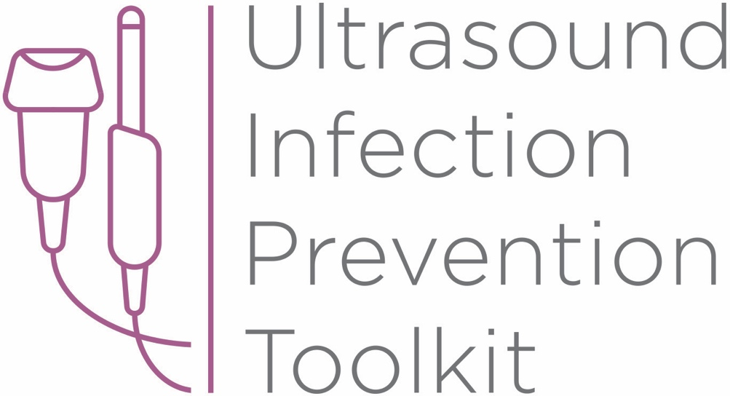

Infection Prevention Toolkit
Prevention of Infection during
Ultrasound Probe Use and Reprocessing

http://www.ultrasoundinfectionprevention.org/

Foreword
This toolkit has been assembled in consultation with clinical experts with backgrounds in infection prevention and instrument reprocessing. The objective in developing this toolkit has been to provide a resource regarding infection prevention during the use and reprocessing of ultrasound probes.
The following individuals have contributed to the development of this toolkit:
Sue Barnes RN CIC FAPIC
Roy Boukidjian MSN PHN CIC
Ruth Carrico PhD DNP APRN FSHEA CIC
Robert Garcia BS MT CIC
Sylvia Garcia-Houchins RN MBA CIC
Amy Nichols RN MBA CIC FAPIC
Rose Seavey MBA BS RN CNOR CRCST CSPDT
John Whelan BSN RN

Approach and Principles
These tools have been assembled based on best practice guidelines with the goal of reducing infection risks associated with ultrasound use in the interest of patient safety. Guidelines referenced in this toolkit are evidence-based, have been developed with infection prevention representation and have followed a formal guideline development process, including a public comment period. These tools are intended to guide the development of institutional policies and procedures, with an understanding that each institution can vary in the patient groups cared for, settings and the types of care provided.

Contents
Tool 1: Part A - Locate
This list of strategies can help locate ultrasound machines in your facility. Locating ultrasound machines can be a challenging task, as they may move around, be uncatalogued, or may be unknown to personnel with responsibility for probe use and reprocessing.
Tool 1: Part B - Profile
After locating ultrasound machines with the Locate tool, this audit tool can be used to observe and assess procedure-specific ultrasound policy and practice. First record the procedure and department, then work through the profile form. The questions guide the user through their policy and an observation checklist is provided to record actual practice. The tool leads the user to an action plan if there is no policy, or if there are discrepancies among policy, practice and guidelines.
Tool 2: Algorithm
This tool is organized by department and provides a range of typical procedures that may be encountered in that department. Probe use and reprocessing requirements based on federal guidelines (CDC and FDA) and national standards (AAMI) are presented as a decision-making algorithm. The flow chart can be printed out and displayed throughout office and procedure rooms and used as a quick reference chart for healthcare workers to determine whether practice is compliant with available guidelines.
Tool 3: Example Risk Assessment
This tool contains four editable templates designed to guide the assessment of potential hazards that may be encountered during the use and reprocessing (cleaning, disinfection, storage) of ultrasound probes. A sample risk matrix is provided with further instructions for completion. A facility should aim to mitigate all significant harm to the lowest risk rating. If that is not possible, the existing workflow and/or products should be reconsidered.
Tool 4: Policy Development Framework
This tool is a policy development framework designed to help develop infection prevention policies for all settings where ultrasound technology is used and probes are reprocessed. It can be used to develop a universal hospital policy or a department-specific policy and has been developed based on major guidelines, standards and evidence-based scientific literature.

Funding

The development of this toolkit has been supported by Nanosonics Ltd. Nanosonics Ltd strives to improve the safety of patients, clinics, their staff and the environment by transforming the way infection prevention practices are understood and conducted and introducing innovative technologies that deliver improved standards of care.

Important Note

This toolkit contains general guidance. Consider this guidance in light of the user’s own professional advice and specific regulations, guidelines, policies and procedures of each region, institution and department. This tool does not replace manufacturer instructions for use (IFUs), nor does it replace institutional policy/workflows, but it is intended to be used in conjunction with them. This Important Note applies to all parts of this toolkit.

Disclaimer

Nanosonics will not accept responsibility of any kind for reliance on this tool or related materials and opinions, including any death or injury to persons. The information, materials and opinions contained here are for general information purposes only, are not intended to constitute legal or other professional advice and should not be relied on or treated as a substitute for specific advice relevant to particular circumstances. We make no warranties, representations or undertakings about the content (including, without limitation, the quality, accuracy, completeness or fitness for any particular purpose of such content). This Disclaimer applies to all parts of this tool and every department.

Infection Prevention Toolkit
Tool 1
Locate and Profile
Instructions

Tool 1: Part A – Locate
Locate the departments/clinics using ultrasound at your facility.

The options listed can be used to determine where ultrasound is used in order to facilitate follow up on any issues related to infection prevention. Different options below may be relevant based on the type and size of your facility. More than one strategy may be used in attempting to locate ultrasound machines. Strategies are ranked in order of assumed effectiveness.

Tool 1: Part B – Profile
Profile policy and practice for each ultrasound procedure
at your facility.

After locating ultrasound machines with the Locate tool, this audit tool can be used to observe and assess procedure-specific ultrasound policy and practice. The page can be printed and ultrasound procedures for each facility area can be used for individual observation sessions. First record the procedure and department, then work through the profile form. The questions guide the user through their policy and an observation checklist is provided to record actual practice. The tool leads the user to an action plan if there is no policy, or if there are discrepancies between policy, practice and guideline.
Tool 1: Part A – Locate
Locate the departments/clinics using ultrasound at your facility.
Strategy | Rationale | How | Limitations
1. Locate where ultrasound machines are by searching the organization’s asset register. | Clinical/Biomedical Engineering department maintains an asset register of equipment used throughout the facility. The asset register links the ultrasound machine and associated service contracts to department locations. | Ask the Clinical/Biomedical Engineering department to provide a complete list of ultrasound probes and consoles from their asset register. Identify the department in which they are located. | - Not all ultrasound machines may be listed on the register.  - Asset registers may be incomplete (e.g., due to mergers/acquisitions, purchases being made by local departments, trial equipment is being used or other reasons).
2. Locate where ultrasound consumables are being used (e.g., gel, probe sheaths/covers). | All ultrasound probes are used with ultrasound gel which is essential for imaging quality. Some ultrasound probes are used with sheaths/covers. Locating ultrasound gel and probes covers will lead to the departments using ultrasound probes. | Approach materials management, purchasing or supply chain management and request they search purchase orders and inventory lists for each department/the facility, and provide a report of material. | - It may be difficult to obtain purchase orders and inventory, particularly if a central system is not in place.  - Some consumables may be ordered centrally and distributed or may be ordered and purchased locally (e.g., by individual departments or units).
3. Survey departments to identify where ultrasound is used. | End users are the best placed to know where ultrasound is being used. | Approach departments and ask about their ultrasound use. Methods include but are not limited to departmental/facility wide email, physically visiting or phoning each department and/or patient care unit leadership. | - It may be time consuming to reach all departments.  - It may be difficult to identify staff with full knowledge of ultrasound use in their department.
4. Identify billable ultrasound procedures in financial records. | Ultrasound procedures should be billed. If ultrasound procedure item codes are obtained, they can then be used to identify which departments or providers are billing for those items. | Identify ultrasonography billing codes, ask finance department for a list of billing records that involve ultrasound procedure item codes and determine which departments are billing for those items. | - Billing may not provide department specific information.  - The finance system may not be set up to readily perform these searches.  - It may be difficult to determine which item codes are associated with ultrasound procedures or probes.

Tool 1: Part B – Profile
Profile policy and practice for each ultrasound procedure at your facility.

Procedure | Department | Room | Date | Assessor

1. Policy. Does the facility/department have a policy for performing ultrasound procedures?

□ Yes. Go to Q2. | □ No. Go to Q4.

2. Read Your Policy. How does the policy indicate the probe should be reprocessed and used for this particular procedure?

Reprocessing: | □ Sterilized | □ HLD | □ LLD/ILD | □ Not specified
Cover use: | □ Sterile | □ Single use non-sterile | □ None | □ Not specified
Gel use: | □ Single use sterile | □ Single use non-sterile | □ Multiuse bottle | □ Not specified

3. Assess Your Policy. Is the policy consistent with manufacturer instructions for use and guideline recommendations for this procedure? Refer to Tool 2 for procedure specific information.

□ Yes | □ No, but policy contains justification for deviation | □ No

4. Observe Practice. How is the probe reprocessed and used by the end users for this procedure?

Reprocessing: | □ Sterilized | □ HLD | □ LLD/ILD
Cover use: | □ Sterile | □ Single use non-sterile | □ None
Gel use: | □ Single use sterile | □ Single use non-sterile | □ Multiuse bottle

5. Assess Practice. Is the observed practice compliant with your policy?

□ Yes | □ No | □ No policy in place
6. Were any shaded options selected?

□ Yes. Go to Q7. | □ No. Congratulations, your policy and practice are compliant. No further action needed. File this form and ensure ongoing training for all users.

7. Action Plan Required. Your policy needs updating or users are not trained according to your policy/procedure. Note action and effectiveness review date below for each shaded option.
Effectiveness Review Date: ___/___/___

