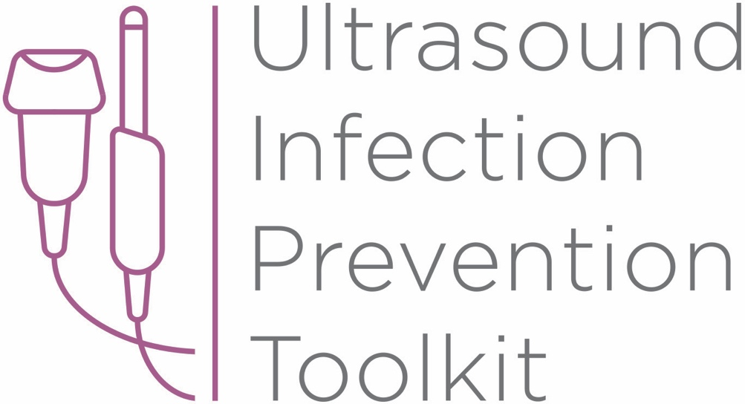

Infection Prevention Toolkit
Prevention of Infection during
Ultrasound Probe Use and Reprocessing
http://www.ultrasoundinfectionprevention.org/

Foreword
This toolkit has been assembled in consultation with clinical experts with backgrounds in infection prevention and instrument reprocessing. The objective in developing this toolkit has been to provide a resource regarding infection prevention during the use and reprocessing of ultrasound probes.
The following individuals have contributed to the development of this toolkit:
Sue Barnes RN CIC FAPIC
Roy Boukidjian MSN PHN CIC
Ruth Carrico PhD DNP APRN FSHEA CIC
Robert Garcia BS MT CIC
Sylvia Garcia-Houchins RN MBA CIC
Amy Nichols RN MBA CIC FAPIC
Rose Seavey MBA BS RN CNOR CRCST CSPDT
John Whelan BSN RN

Approach and Principles
These tools have been assembled based on best practice guidelines with the goal of reducing infection risks associated with ultrasound use in the interest of patient safety. Guidelines referenced in this toolkit are evidence-based, have been developed with infection prevention representation and have followed a formal guideline development process, including a public comment period. These tools are intended to guide the development of institutional policies and procedures, with an understanding that each institution can vary in the patient groups cared for, settings and the types of care provided.

Contents
Tool 1: Part A - Locate
This list of strategies can help locate ultrasound machines in your facility. Locating ultrasound machines can be a challenging task, as they may move around, be uncatalogued, or may be unknown to personnel with responsibility for probe use and reprocessing.
Tool 1: Part B - Profile
After locating ultrasound machines with the Locate tool, this audit tool can be used to observe and assess procedure-specific ultrasound policy and practice. First record the procedure and department, then work through the profile form. The questions guide the user through their policy and an observation checklist is provided to record actual practice. The tool leads the user to an action plan if there is no policy, or if there are discrepancies among policy, practice and guidelines.
Tool 2: Algorithm
This tool is organized by department and provides a range of typical procedures that may be encountered in that department. Probe use and reprocessing requirements based on federal guidelines (CDC and FDA) and national standards (AAMI) are presented as a decision-making algorithm. The flow chart can be printed out and displayed throughout office and procedure rooms and used as a quick reference chart for healthcare workers to determine whether practice is compliant with available guidelines.
Tool 3: Example Risk Assessment
This tool contains four editable templates designed to guide the assessment of potential hazards that may be encountered during the use and reprocessing (cleaning, disinfection, storage) of ultrasound probes. A sample risk matrix is provided with further instructions for completion. A facility should aim to mitigate all significant harm to the lowest risk rating. If that is not possible, the existing workflow and/or products should be reconsidered.

Tool 4: Policy Development Framework
This tool is a policy development framework designed to help develop infection prevention policies for all settings where ultrasound technology is used and probes are reprocessed. It can be used to develop a universal hospital policy or a department-specific policy and has been developed based on major guidelines, standards and evidence-based scientific literature.

Funding

The development of this toolkit has been supported by Nanosonics Ltd. Nanosonics Ltd strives to improve the safety of patients, clinics, their staff and the environment by transforming the way infection prevention practices are understood and conducted and introducing innovative technologies that deliver improved standards of care.

Important Note

This toolkit contains general guidance. Consider this guidance in light of the user’s own professional advice and specific regulations, guidelines, policies and procedures of each region, institution and department. This tool does not replace manufacturer instructions for use (IFUs), nor does it replace institutional policy/workflows, but it is intended to be used in conjunction with them. This Important Note applies to all parts of this toolkit.

Disclaimer

Nanosonics will not accept responsibility of any kind for reliance on this tool or related materials and opinions, including any death or injury to persons. The information, materials and opinions contained here are for general information purposes only, are not intended to constitute legal or other professional advice and should not be relied on or treated as a substitute for specific advice relevant to particular circumstances. We make no warranties, representations or undertakings about the content (including, without limitation, the quality, accuracy, completeness or fitness for any particular purpose of such content). This Disclaimer applies to all parts of this tool and every department.

Infection Prevention Toolkit
Tool 4
Policy Development Framework

This tool is a policy development framework designed to help develop infection prevention policies and to be applied to all settings where ultrasound is used and reprocessed. It can be used to develop a universal hospital policy or a department specific policy and has been developed based on major guidelines, standards and evidence-based scientific literature.
Purpose and Scope
This tool has been developed for healthcare personnel developing infection prevention policies for ultrasound probe use and reprocessing. It is an editable document designed as a policy framework for application in all settings where ultrasound is used. This framework can be used to develop a universal hospital policy or a department-specific policy. See Instructions.
This tool is based on federal guidelines (CDC and FDA), national standards (AAMI) and evidence-based scientific literature. It is a general document that will need to be modified in line with the specific regulations, guidelines, policies and procedures of each region, institution and department. All manufacturer instructions for use (MIFU) must be consulted prior to use. This tool covers the following aspects related to ultrasound probe use and reprocessing: cleaning, disinfection/sterilization, storage, ultrasound use (gel, probe covers), responsibilities, education and training.

Instructions
This document is completely editable. Read through each section and modify so that the policy applies to your clinical setting.
When customizing a policy for your facility/department/processes, consider the probe models used, ultrasound procedures performed, whether the policy is department-specific or hospital-wide, and the existing reprocessing workflows currently in use.

Blue boxed text specifies further instructions for each section.

Ultrasound Infection Control Policy

1. Revision History 4
2. Abbreviations 4
3. Scope 4
4. Overview of Ultrasound Probe Reprocessing and Use 5
5. Ultrasound Probe Reprocessing 6
5.1 Cleaning 6
5.2 Disinfection and Sterilization 7
5.2.1 Assigning the Spaulding Classification of the Probe 7
5.2.2 Methods of Disinfection and Sterilization 9
5.2.3 Disinfection/Sterilization Cycle Validation 10
5.2.4 Inadequate Reprocessing 11
5.2.5 Rinsing and Drying 11
5.2.6 Transport and Storage 12
5.2.7 Traceability 13
6. During an Ultrasound Procedure 13
6.1 General 13
6.2 Probe Barriers 14
6.3 Gel Use 14
7. Staff and Responsibilities 15
7.1 Supervisory Personnel 16
7.2 Reprocessing Personnel 16
7.3 Training 17
8. Evaluating Changes to Products and Processes 18
9. References 19

1. Revision History
Date | Revision Number | Change(s) | Reference Section

2. Abbreviations
AAMI – Association for the Advancement of Medical Instrumentation
AER – Automated Endoscope Reprocessor
ANSI – American National Standards Institute
CDC – Centers for Disease Prevention and Control
CSPD – Central Sterile Processing Department
GTA – Glutaraldehyde
HLD – High-level disinfection
LLD – Low-level disinfection
MIFU – Manufacturer instructions for use
OPA – Ortho-phthalaldehyde
PPE – Personal protective equipment
SOP – Standard operating procedure
WHO – World Health Organization

3. Scope
This policy defines the requirements for ultrasound probe use and reprocessing at [specify facility/department]. All healthcare workers that use ultrasound in procedures, perform the reprocessing of ultrasound probes, and/or oversee the reprocessing and use of ultrasound should be trained and competent in this policy.
‘Ultrasound probe’ refers to external ultrasound probes (e.g., surface, Doppler, linear probes) and non-lumened endocavitary probes (e.g., transvaginal, transrectal and transesophageal probes).
Update this Scope to specify facility/department.

4. Overview of Ultrasound Probe Reprocessing and Use

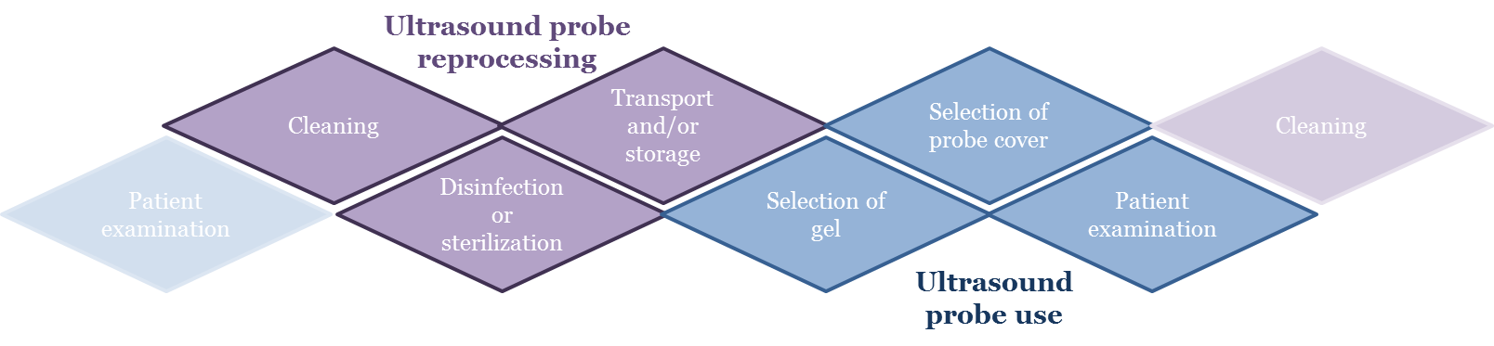
Figure 1. Stages of ultrasound probe reprocessing and use covered in this policy. Traceability needs to be incorporated throughout this process (see Traceability).

The steps in ultrasound probe reprocessing and use are summarized in Figure 1. The steps are probe cleaning, disinfection/sterilization, transport/storage, gel selection, cover selection and patient use. The information in these steps need to be linked (traceability) and responsibilities throughout this process must be clearly defined.
The requirements in this policy relating to ultrasound reprocessing and use have been developed based on the reusable medical device reprocessing requirements in the ANSI/AAMI Standard ST58:2013 Chemical Sterilization and High-Level Disinfection in Health Care Facilities (‘AAMI Standards’), specific ultrasound use and reprocessing requirements in the CDC 2008 Guideline for Disinfection and Sterilization in Healthcare Facilities (‘CDC Guidelines’) and FDA guidelines, including the FDA 2008 guideline, Information for Manufacturers Seeking Marketing Clearance of Diagnostic Ultrasound Systems and Transducers.¹⁻⁵ Where elements relate to facility accreditation, reference is made to the Centers for Medicare and Medicaid Services (CMS) Infection Control Worksheet.⁶
This policy also follows recommendations from the manufacturer instructions for use (MIFUs) of chemical sterilants, high-level disinfectants, reprocessing equipment and ultrasound probes used at this facility to ensure compatibility with probe materials.
This policy complies with the following local and state regulation/policies [list relevant regulations].
Update this overview to specify relevant regulations.

5. Ultrasound Probe Reprocessing

5.1 Cleaning
Cleaning is the essential first step in reprocessing. Improper cleaning could render subsequent disinfection or sterilization ineffective. The CDC Guidelines define cleaning as “…the removal of visible soil (e.g., organic and inorganic material) from objects and surfaces.”² This is generally accomplished manually or mechanically and may include a rinsing step (See ‘Rinsing and Drying’).^{1,2}
Extra care should be taken when cleaning probes that have indentations or complex surfaces. The probe MIFU should always be consulted for cleaning instructions and lists of compatible products. Typical cleaning solutions indicated for use with ultrasound probes include detergent-based cleaning wipes, detergent in combination with running water and enzymatic cleaning agents. The cleaning method should be indicated for use on ultrasound probes, be effective, be compatible with the probe and be safe for the user. Ensure appropriate PPE is available for staff to undertake the cleaning process. Perform rinsing if required by the MIFU of the cleaning product. At the conclusion of the cleaning process, the probe should be dried to prevent interference in subsequent steps.
According to AAMI Standards and CDC Guidelines, cleaning should be confirmed by visual inspection before the device is disinfected or sterilized.^{1,2}
Note the cleaning process used in your department/facility and reference or specify the standard operating procedure (SOP) here.

5.2 Disinfection and Sterilization

5.2.1 Assigning the Spaulding Classification of the Probe
Each ultrasound probe should be classified according to the Spaulding criteria based on its intended use. Medical devices can be classified into three categories based on the patient tissues they contact and associated infection transmission risk. The Spaulding classification system dictates the level of disinfection/sterilization required for the ultrasound probe.¹⁻⁵
Non-critical ultrasound probes
- Will only contact healthy intact skin, and will not contact mucous membranes, the bloodstream or sterile tissues.
- Require a minimum of low-level disinfection (LLD).
- Example procedures where the ultrasound probe is non-critical include abdominal scans on healthy skin.

Semi-critical ultrasound probes
- Contact mucous membranes or non-intact skin (e.g., skin with abrasions, dermatitis, chapped skin, rash, psoriasis). Semi-critical probes do not contact sterile tissues or the bloodstream.
- Require a minimum of high-level disinfection (HLD) so that the device is free from all microorganisms except for a small number of bacterial spores.
- Example procedures where the ultrasound probe is semi-critical include:
  - Endocavitary ultrasound of healthy mucosa (e.g., transvaginal, transrectal, transesophageal echocardiography scans)
  - Abdominal or other diagnostic scans on non-intact skin
- Surface wound assessment (e.g., partly healed wound).
- In the event semi-critical ultrasound probes are used in conjunction with a sheath, the probe still requires HLD.^{2,3}

Critical ultrasound probes
- Contact or enter sterile body cavities, sterile tissue or the vascular system.
- Confer high risk for infection transmission if they are contaminated with any microorganism.
- Require sterilization to be free from all viable microorganisms.
- In general, critical ultrasound probes include those used in surgical procedures and some ultrasound guided interventions (e.g., biopsies and other percutaneous procedures where the probe can contact the puncture site). These invasive procedures require a sterile field and sterile instrumentation as they access sterile body sites.
- The CDC guidelines state specifically for critical ultrasound probes, if sterilization of the probe is not possible, the probe can undergo HLD and be used with a sterile sheath.²

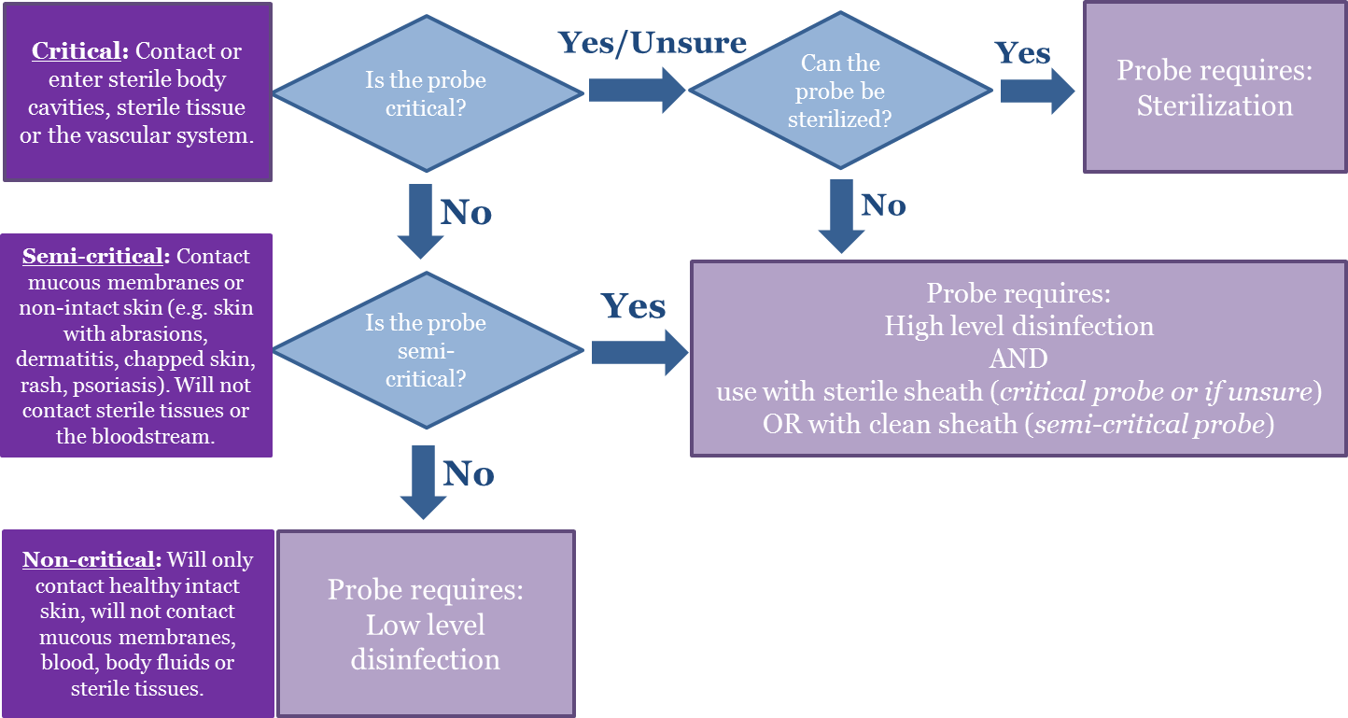
Figure 2. A flowchart decision tree to determine the level of reprocessing and sheath type required before use of an ultrasound probe on a patient.

Apply the above rationale to the procedures used in your department/facility. List the procedures performed and assign the Spaulding classification of the probe and sheath and reference or specify the SOP here. For peripheral IVs, mid-lines and PICCs, multiple attempts at placing these lines may increase the risk of bacteremia.¹⁶ Ultrasound guidance generally reduces the number of attempts at placement. Where HLD would prevent the use of ultrasound for these procedures, the relative risks need to be considered. It is important that patients undergoing peripheral vascular access continue to receive ultrasound guidance. Institutions need to consider all risks to a patient as a result of changing practice for peripheral vascular access, including the practicalities of performing HLD and the need to continue to provide ultrasound guidance for these procedures. A multi-disciplinary team should be assembled to consider these risks.

5.2.2 Methods of Disinfection and Sterilization
It is important to ensure that sterilization or HLD is compatible with the ultrasound probe such that probe integrity is not compromised. Examples of ultrasound probe sterilants and high-level disinfectants are listed in Table 1, however the probe MIFU must always be consulted to confirm compatibility before use. The CDC Guidelines and AAMI Standards provide general information on the chemicals listed in Table 1.^{1,2}

Table 1. Examples of different disinfection and sterilization methods that may be compatible with ultrasound probes. Always consult MIFUs before selecting a reprocessing method for the probe model.
Sterilization | High-Level Disinfection (HLD) | Low-Level Disinfection (LLD)
Ethylene oxide  Hydrogen peroxide  Chemical sterilant soaks (e.g., OPA or GTA at extended contact times) | Automated sonicated hydrogen peroxide mist  Manual GTA soaks  Manual OPA soaks  Accelerated hydrogen peroxide soaks | Quaternary ammonium wipes  Quaternary ammonium sprays

Note the disinfection/sterilization process used in your department/facility and reference or specify the SOP here.

5.2.3 Disinfection/Sterilization Cycle Validation
Whether the sterilization/HLD process is manual or automated, monitoring the success and efficacy of the cycle is important in ensuring proper probe reprocessing.^{1,2} Types of monitors are shown in Figure 3. The MIFU should be followed to determine monitor frequency, placement and interpretation of results. If possible, results from several monitor types should be used collectively as a part of process validation.
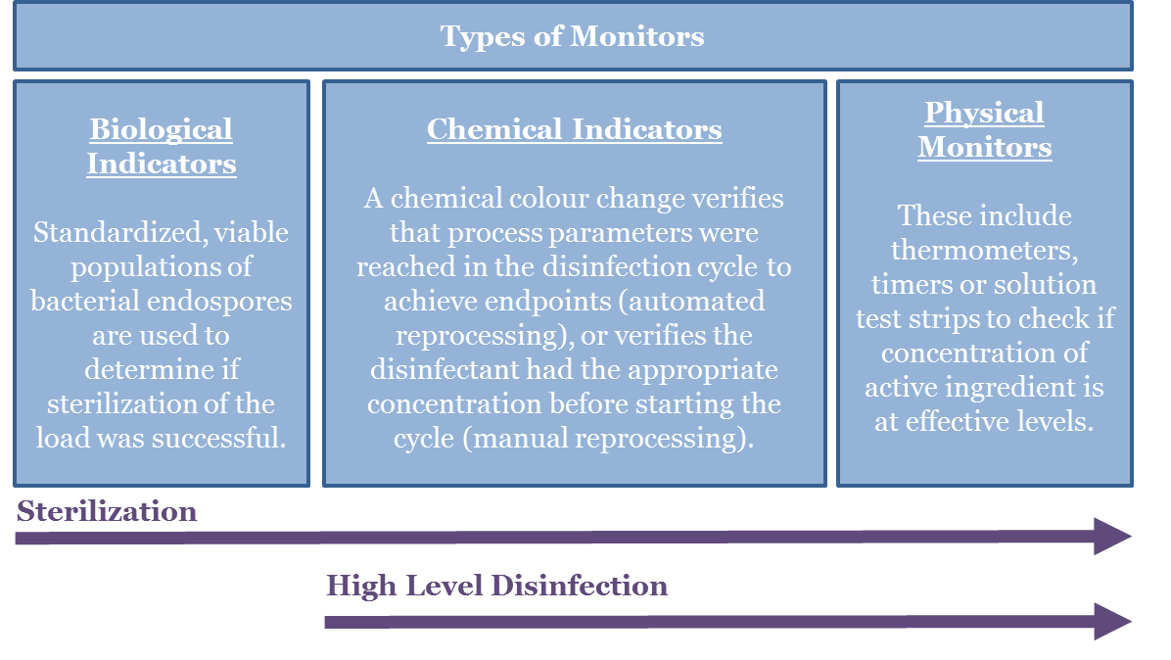
Figure 3. A summary of different types of monitors which can be employed for process validation.

As part of cycle validation, ensure monitor results are documented and stored to facilitate traceability. Also ensure staff are trained regularly in their use and interpretation.^{1,2}
Note the validation processes required in the MIFU for your disinfection/sterilization process and reference or specify the SOP here.

5.2.4 Inadequate Reprocessing
If a reprocessing cycle fails, ensure the probe is not used on the patient and repeat the cycle on the probe. If the cycle passes, continue workflow as usual. In the event of multiple reprocessing cycle failures, take the following steps (adapted from the AAMI Standards):²
1. Refer to the disinfectant/sterilization MIFU to troubleshoot. If troubleshooting is unsuccessful, document and report the process/device and nature of failure and remove from service.

2. Head of department, risk management or infection control department and others per local protocol should be immediately notified. An investigation should be conducted to assess any patient harm and a decision made regarding patient notification.

3. After the problem is corrected, the process/device should be thoroughly validated (via a range of monitors and/or diagnostic cycles) before being returned to service.

Note disinfection/sterilization process specific steps required in the event of a reprocessing failure at your facility here or reference the SOP.

5.2.5 Rinsing and Drying
Sterilization in terminal barriers does not require any rinsing or drying. For liquid chemical sterilization or high-level disinfection, refer to the MIFU to determine rinsing and drying requirements. Determine the number of rinses (if required), the quality of rinse water that should be used (e.g., potable, deionized, sterile) and drying method (e.g., clean, lint free towel or wipe or air dry).^{1,2}
List requirements here or reference SOP.

5.2.6 Transport and Storage
If the reprocessing workflow requires probe transportation, the following requirements should be met (adapted from AAMI Standards):¹
- The probe cover and any gel should be removed immediately after the examination and prior to transportation.
- Dirty (i.e. contaminated/used) probes should be transported in containers with a biohazard label or other means of identifying contaminated contents.
- Transport routes should facilitate easy maneuvering and avoid high areas of traffic.
- Disinfected/sterile probes should remain separate from contaminated probes at all times and be transported in clean containers.

According to AAMI Standards, medical devices after reprocessing should be either immediately used or stored in a manner that prevents recontamination before next patient use.¹ Applying this to ultrasound probes, terminally sterilized probes can be stored in their terminal barrier or container they were sterilized in. Probes that have undergone liquid chemical sterilization should not be stored and should be used immediately. For probes that have undergone HLD, ensure that:
- The storage location supports the clinical workflow and patient throughput (e.g., on the console, in a cabinet in the treatment room, in a separate room).
- A storage method is selected to prevent contamination from the environment. For example, use a clean single-use storage cover when storing on the console or cabinet.
- Probes are dry before being stored.
- Probes are labeled to distinguish whether probe has undergone LLD, HLD or sterilization and dated (e.g., on the probe storage cover).
- Probes are stored in a manner which will prevent cables and plug (which do not typically undergo HLD) from contacting the probe handle or body.
- A risk assessment should be conducted to determine the maximum storage time for probes.

High-level disinfected and sterilized items should be protected from contamination and delivered aseptically to the point of use.
Update this section with facility/department specific transportation (if required for the disinfection process used) and storage requirements. Ensure requirements above are addressed and considered. Reference any relevant SOPs.

5.2.7 Traceability
Documentation is essential for retrospective investigations associated with gaps or failures in reprocessing, and outbreaks of infection. Documentation, record keeping and monitoring of chemical sterilization processes and high-level disinfection processes is required for traceability and quality control.^{1,2}
According to AAMI Standards, the following data should be recorded and linked to the patient the device is used upon: probe ID, lot number, cycle number, shelf-life date, exposure time, temperature, chemical disinfectant concentration, relevant validation monitor results (e.g., chemical indicator result to ensure the minimum effective concentration was met), date, time, reprocessing staff ID, patient ID on which the device will be used, procedure and physician details.¹ All reprocessing failures or inconclusive results also need to be recorded and the procedures outlined in ‘Inadequate Reprocessing’ followed.
According to AAMI standards, records should be maintained for a period of time no less than that specified by state or local statutes.¹ If not specified, AAMI recommends retention time should be determined in conjunction with the facility’s risk management department and infection and prevention control committee. Traceability can be achieved manually with stickers and logbooks or with electronic record keeping systems.¹
Update this section with your disinfection/sterilization process and workflow specific traceability process. Ensure above requirements are met and specify methods and information that needs to be collected, linked, stored and maintained.

6. During an Ultrasound Procedure

This section expands on probe barrier use and specifies gel use requirements based on the Spaulding classification of the ultrasound probe. This rationale should be applied to each procedure in your facility/department and specified.

6.1 General
It is important to ensure all equipment necessary for the procedure is adequately reprocessed before use. Additionally, proper protocols should be used to prevent cross-contamination between surfaces, probes, operators and the patient.
It is also important to remember that unexpected changes in patient circumstances may occur and will require considering whether the selected probe is still appropriate for the upcoming procedure. For example, the patient may present with non-intact skin (e.g., dermatitis, rash or wound) when intact skin was expected. This would make the probe semi-critical instead of non-critical and will consequently require HLD versus LLD.
See Disinfection and Sterilization for assigning the Spaulding classification to the probe.

6.2 Probe Barriers
Probe sheaths (e.g., dedicated covers, condoms) are an additional layer of protection to prevent excessive soiling and to minimize the chance of cross-contamination between patients. Sheaths are available sterile and non-sterile (usually clean-room manufactured). Condoms are typically non-sterile.
Federal guidelines (CDC and FDA) require endocavitary probes undergo high-level disinfection and be used with a single-use sheath.^{2,3} They require critical probes undergo sterilization, and if this is not possible, the CDC provides the concession to minimally high-level disinfect these probes with use of a sterile sheath.² This applies to probes used intraoperatively, in biopsies and other percutaneous interventions where there is contact with the puncture site.^{2,3}
Studies have demonstrated the high frequency of probe sheath perforation rates, occurrences of probe sheath contamination post procedure and difficulties involved with visually determining probe sheath breaches and perforations.⁷⁻¹³ The CDC and FDA are in agreement that use of a probe cover does not negate the need for high-level disinfection or sterilization of the probe:^{2,3}
“Do not use a lower category of disinfection or cease to follow the appropriate disinfectant recommendations when using probe covers because these sheaths and condoms can fail.”²
See Disinfection and Sterilization for assigning the Spaulding classification to the probe and the associated cover use.
6.3 Gel Use
Ultrasound coupling gel is necessary to allow passage of the ultrasound energy into patient tissues and is required for a good quality image. It is used in almost all ultrasound procedures. As such, policy describing safe handling and use is paramount to reducing and preventing cross-contamination. Numerous outbreaks from contaminated ultrasound gel have been reported in the literature. In some cases, these infections have been associated with invasive procedures such as ultrasound-guided central venous catheter placement, pericardiocentesis, amniocentesis and surgeries.¹⁴⁻¹⁶ Gel is typically available in single-use sachets (sterile and non-sterile) as well as in non-sterile multi-use gel bottles. Careful selection of the correct type of gel is important for preventing infections. A rationale for sterility requirements for gel use can be derived from the Spaulding classification. For critical items, sterile gel should be used. For semi-critical, a minimum of single-use clean-room manufactured gel should be used. For non-critical a minimum of multi-use gel can be used (Table 2).
After completion of the procedure, the probe should be immediately cleaned and all visible gel and bioburden removed before subjecting the probe subsequent reprocessing steps. Relevant staff should be educated regarding the use of probe covers and ultrasound coupling gel and competency regularly checked.

Table 2. Ultrasound gel use during ultrasound guided procedures
Critical probes | Semi-critical probes | Non-critical probes
Sterile single-use gel | Non-sterile single-use gel at a minimum  Sterile single-use gel preferred | Multi-use, non-refillable gel acceptable
Considerations | Considerations | Considerations
Use aseptic technique when handling  Sterile single-use gel is the minimum requirement for invasive procedures where there is risk of the probe and gel contacting sterile tissue and blood | Use aseptic technique when handling | Avoid multi-use gel where possible. Single-use gels preferred  If used, care should be taken not to touch the patient or probe with the tip of the multi-use gel bottle  Discard multi-use bottles based on facility policy and MIFU  Refillable bottles should be avoided due to established risk of bacterial growth  Generally, gel warmers should not be used due to the risk of pathogen growth
General considerations (all gel)
- Ensure gel is only used within its shelf life
- Store gel protected from sources of contamination (e.g., dust, moisture)
- Check before use for evidence of contamination

7. Staff and Responsibilities
The levels of staff and corresponding reprocessing responsibilities may vary depending on the size and structure of healthcare facilities. According to AAMI Standards, assigning responsibility is important for accountability and effective patient safety.¹

7.1 Supervisory Personnel
Supervisory personnel oversee all reprocessing and use activities described in this policy. AAMI recommends they are trained in instrument reprocessing, participate in continuing education programs on management (personnel, material, financial) and leadership, and participate in other courses related to the management position with special emphasis on infection prevention and control, safety, and the principles and methods of reprocessing. Supervisory personnel should also have knowledge of relevant local, state and federal regulations and relevant qualifications (e.g., reprocessing certification).¹
Specify supervisory personnel (profession level) at your facility/department here.

7.2 Reprocessing Personnel
Processing personnel should have documented competence in relevant cleaning methods and microbiocidal processes and equipment related to the specific sterilization/HLD process used in the department. Furthermore, they should have knowledge of general sterilization/disinfection and infectious disease transmission principles and aspects of liquid/chemical sterilization/HLD (if relevant), such as:¹
- Reprocessing
- Inspection of cleaning, drying and rinsing processes
- Monitoring of sterilization/HLD processes
- Maintaining documentation for traceability purposes
- Safety with regard to using the equipment and personal hygiene ,
- Use of PPE (where relevant) to protect skin, eyes, mucus membranes and clothing

Processing personnel are also required to participate in ongoing training programs which focus on orientation into the healthcare facilities and their departmental policies, infection prevention and control, use of reprocessing equipment, safety, attire, personal hygiene and compliance with local, state and federal regulations.^{1,2}
Specify reprocessing personnel (profession level) at your facility/department here.

7.3 Training
Staff involved in reprocessing and ultrasound equipment usage should receive orientation training prior to commencing responsibilities. Additionally, annual re-training should be performed for the duration of their employment. Training should establish the knowledge base required to safely perform reprocessing, safely use ultrasound in procedures with the goal of removing operator error, promoting staff and patient safety and, ultimately mitigating infection transmission risks.^{1, 2}
The Centers for Medicare and Medicaid Services Infection Control Worksheet requires surveyors to ensure the facility has documentation of training, competence and qualifications for staff involved in reprocessing.⁶
Specify training requirements and schedule here.

8. Evaluating Changes to Products and Processes
All aspects of this policy should be reviewed with infection prevention and other relevant subject matter experts when setting up the use of ultrasound for the first time, purchasing new ultrasound equipment or, making changes to existing processes. Additional considerations are:
Safety – The CDC guidelines and AAMI standards require staff and patient safety must not be compromised by the chosen reprocessing workflows and processes.^{1,2} Consider chemical exposure risks from bulk liquids and vapors. Work area design considerations must be assessed (e.g., ventilation, designated dirty/clean sinks, hazardous waste disposal units, emergency showers) if required.
Cost – The AAMI standards highlight cost-effectiveness factors that should be evaluated related to equipment (e.g., purchase, service and maintenance), consumables, PPE, energy, disposal costs and training).¹
Reprocessing time – Consider time required to examine patients versus time for reprocessing. If there is high patient turnover, it may be necessary to change the reprocessing procedure or purchase additional probes for effective turnaround time.
Reprocessing location – If probes are reprocessed at point of use, then the disinfection method must be safe for patients and staff. The AAMI standards and CDC guidelines require a dirty to clean workflow during reprocessing.^{1,2} This should be observed regardless of reprocessing location with designated dirty and clean areas to prevent cross-contamination. If transport of dirty or clean devices is required to a central reprocessing area, then a probe transportation protocol must be observed to prevent mixing of dirty and clean instruments (See Transport and Storage).
Automated or manual reprocessing – Consideration should be given to automated versus manual processes. It is well accepted that automated processes minimize the influence of human factors on reprocessing outcomes and should be adopted where possible.¹⁷

9. References

1. American National Standards Institute (ANSI), Association for the Advancement of Medical Instrumentation (AAMI). ST58:2013 Chemical sterilization and high-level disinfection in health care facilities. 2013.

2. Rutala WA, Weber DJ, Healthcare Infection Control Practices Advisory Committee (HICPAC), Centre for Disease Control and Prevention (CDC). Guideline for Disinfection and Sterilization in Healthcare Facilities (Updated 15 February 2017). 2008.

3. Food and Drug Administration (FDA). Information for Manufacturers Seeking Marketing Clearance of Diagnostic Ultrasound Systems and Transducers. 2008.

4. Food and Drug Administration (FDA). Reprocessing Medical Devices in Health Care Settings: Validation Methods and Labeling. 2015.

5. Food and Drug Administration (FDA). Content and Format of Premarket Notification [510(k)] Submissions for Liquid Chemical Sterilants/High Level Disinfectants. 2000.

6. Centers for Medicare and Medicaid Services (CMS). CMS Hospital Infection Control Worksheet, Sections 3A and 3B. Available at: https://www.cms.gov/Medicare/Provider-Enrollment-and-Certification/SurveyCertificationGenInfo/Downloads/Survey-and-Cert-Letter-15-12-Attachment-1.pdf. 2015.

7. Masood J, Voulgaris S, Awogu O, Younis C, Ball AJ, Carr TW. Condom perforation during transrectal ultrasound guided (TRUS) prostate biopsies: a potential infection risk. Int Urol Nephrol. 2007;39(4):1121-4.

8. Amis S, Ruddy M, Kibbler CC, Economides DL, MacLean AB. Assessment of condoms as probe covers for transvaginal sonography. J Clin Ultrasound. 2000;28(6):295-8.

9. Milki AA, Fisch JD. Vaginal ultrasound probe cover leakage: implications for patient care. Fertil Steril. 1998;69(3):409-11.

10. Storment JM, Monga M, Blanco JD. Ineffectiveness of latex condoms in preventing contamination of the transvaginal ultrasound transducer head. South Med J. 1997;90(2):206-8.

11. Rooks VJ, Yancey MK, Elg SA, Brueske L. Comparison of probe sheaths for endovaginal sonography. Obstet Gynecol. 1996;87(1):27-9.

12. Hignett M, Claman P. High rates of perforation are found in endovaginal ultrasound probe covers before and after oocyte retrieval for in vitro fertilization-embryo transfer. J Assist Reprod Genet. 1995;12(9):606-9.

13. Fritz S, Hust MH, Ochs C, Gratwohl I, Staiger M, Braun B. Use of a latex cover sheath for transesophageal echocardiography (TEE) instead of regular disinfection of the echoscope? Clin Cardiol. 1993;16(10):737-40.

14. Abdelfattah R, Aljumaah S, Alqahtani A, Althawadi S, Barron I, Almofada S. Outbreak of Burkholderia cepacia bacteraemia in a tertiary care centre due to contaminated ultrasound probe gel. J Hosp Infect. 2018;98(3):289-94.

15. Shaban RZ, Maloney S, Gerrard J, Collignon P, Macbeth D, Cruickshank M, et al. Outbreak of health care-associated Burkholderia cenocepacia bacteremia and infection attributed to contaminated sterile gel used for central line insertion under ultrasound guidance and other procedures. Am J Infect Control. 2017;45(9):954-58.

16. Cheng A, Sheng WH, Huang YC, Sun HY, Tsai YT, Chen ML, et al. Prolonged postprocedural outbreak of Mycobacterium massiliense infections associated with ultrasound transmission gel. Clin Microbiol Infect. 2016;22(4):382.e1-.e11.

17. Ofstead CL, Wetzler HP, Snyder AK, Horton RA. Endoscope reprocessing methods: a prospective study on the impact of human factors and automation. Gastroenterol nurs. 2010;33(4):304-11.

