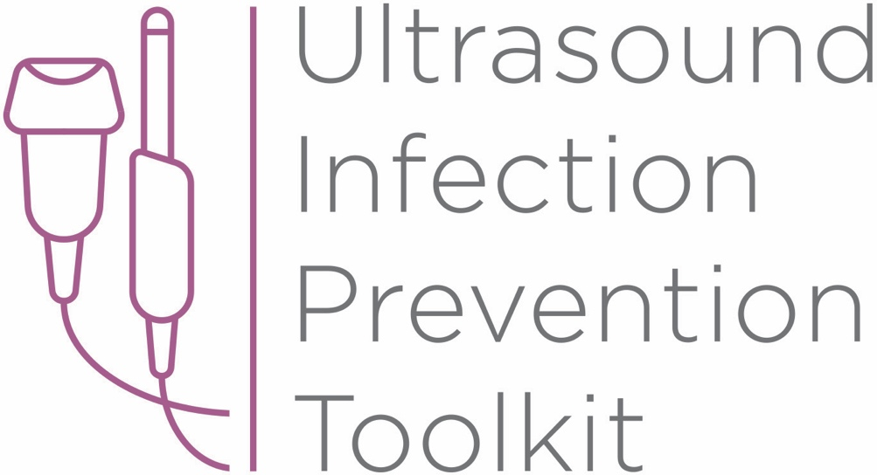

Infection Prevention Toolkit
Prevention of Infection during
Ultrasound Probe Use and Reprocessing
http://www.ultrasoundinfectionprevention.org/
Foreword
This toolkit has been assembled in consultation with clinical experts with backgrounds in infection prevention and instrument reprocessing. The objective in developing this toolkit has been to provide a resource regarding infection prevention during the use and reprocessing of ultrasound probes.
The following individuals have contributed to the development of this toolkit:
Sue Barnes RN CIC FAPIC
Roy Boukidjian MSN PHN CIC
Ruth Carrico PhD DNP APRN FSHEA CIC
Robert Garcia BS MT CIC
Sylvia Garcia-Houchins RN MBA CIC
Amy Nichols RN MBA CIC FAPIC
Rose Seavey MBA BS RN CNOR CRCST CSPDT
John Whelan BSN RN

Approach and Principles
These tools have been assembled based on best practice guidelines with the goal of reducing infection risks associated with ultrasound use in the interest of patient safety. Guidelines referenced in this toolkit are evidence-based, have been developed with infection prevention representation and have followed a formal guideline development process, including a public comment period. These tools are intended to guide the development of institutional policies and procedures, with an understanding that each institution can vary in the patient groups cared for, settings and the types of care provided.

Contents
Tool 1: Part A - Locate
This list of strategies can help locate ultrasound machines in your facility. Locating ultrasound machines can be a challenging task, as they may move around, be uncatalogued, or may be unknown to personnel with responsibility for probe use and reprocessing.
Tool 1: Part B - Profile
After locating ultrasound machines with the Locate tool, this audit tool can be used to observe and assess procedure-specific ultrasound policy and practice. First record the procedure and department, then work through the profile form. The questions guide the user through their policy and an observation checklist is provided to record actual practice. The tool leads the user to an action plan if there is no policy, or if there are discrepancies among policy, practice and guidelines.
Tool 2: Algorithm
This tool is organized by department and provides a range of typical procedures that may be encountered in that department. Probe use and reprocessing requirements based on federal guidelines (CDC and FDA) and national standards (AAMI) are presented as a decision-making algorithm. The flow chart can be printed out and displayed throughout office and procedure rooms and used as a quick reference chart for healthcare workers to determine whether practice is compliant with available guidelines.
Tool 3: Example Risk Assessment
This tool contains four editable templates designed to guide the assessment of potential hazards that may be encountered during the use and reprocessing (cleaning, disinfection, storage) of ultrasound probes. A sample risk matrix is provided with further instructions for completion. A facility should aim to mitigate all significant harm to the lowest risk rating. If that is not possible, the existing workflow and/or products should be reconsidered.

Tool 4: Policy Development Framework
This tool is a policy development framework designed to help develop infection prevention policies for all settings where ultrasound technology is used and probes are reprocessed. It can be used to develop a universal hospital policy or a department-specific policy and has been developed based on major guidelines, standards and evidence-based scientific literature.

Funding

The development of this toolkit has been supported by Nanosonics Ltd. Nanosonics Ltd strives to improve the safety of patients, clinics, their staff and the environment by transforming the way infection prevention practices are understood and conducted and introducing innovative technologies that deliver improved standards of care.

Important Note

This toolkit contains general guidance. Consider this guidance in light of the user’s own professional advice and specific regulations, guidelines, policies and procedures of each region, institution and department. This tool does not replace manufacturer instructions for use (IFUs), nor does it replace institutional policy/workflows, but it is intended to be used in conjunction with them. This Important Note applies to all parts of this toolkit.

Disclaimer

Nanosonics will not accept responsibility of any kind for reliance on this tool or related materials and opinions, including any death or injury to persons. The information, materials and opinions contained here are for general information purposes only, are not intended to constitute legal or other professional advice and should not be relied on or treated as a substitute for specific advice relevant to particular circumstances. We make no warranties, representations or undertakings about the content (including, without limitation, the quality, accuracy, completeness or fitness for any particular purpose of such content). This Disclaimer applies to all parts of this tool and every department.

Infection Prevention Toolkit
Tool 2
Algorithm
This tool is organized by department and provides a range of typical procedures that may be encountered in that department. Probe use and reprocessing requirements based on federal guidelines (CDC and FDA) and national standards (AAMI) are presented as a decision-making algorithm. The printable flow chart can be displayed throughout office and procedure rooms as a quick reference chart for healthcare workers to determine whether practice is compliant with available guidelines.
This tool can also be used in conjunction with Tool 1: Part B – Profile to determine whether policy and practice comply with best practice recommendations.
Guidelines
The following tool is based on the Spaulding classification system which is referenced in the Centers for Disease Control and Prevention (CDC) guidelines and American National Standards Institute (ANSI)/Association for the Advancement of Medical Instrumentation (AAMI) standards.^{1,2} The Centers for Medicare & Medicaid Services (CMS) and The Joint Commission (TJC) refer to these documents for accreditation of health care facilities, and are consistent with the US Food and Drug Administration (FDA) guidance documents.³⁻⁷
The Spaulding classification system dictates the level of disinfection or sterilization a medical device should be subjected to based on the degree of infection risk involved with its use and contact sites in patients. The definitions below are drawn from CDC, FDA and AAMI:
Non-critical devices – only contact intact patient skin and do not penetrate skin or contact mucous membranes. They require low-level disinfection (LLD).
Semi-critical devices – contact mucous membranes or non-intact skin, but do not ordinarily enter the bloodstream or other normally sterile areas of the body. Examples of non-intact skin include skin with cuts, abrasions, dermatitis, chapped skin, rash, psoriasis, broken skin, burns, cellulitis. At a minimum, they require high-level disinfection (HLD).
Critical devices – enter or contact sterile tissue, the bloodstream or are introduced into sterile body cavities during use. They require sterilization.
The classification of an ultrasound probe as a non-critical device is limited to use in external scans across healthy skin (e.g., transabdominal scans). Semi-critical ultrasound probes are those used in endocavitary scans (e.g., transvaginal, transrectal) and external scans with non-intact skin in the scan region. The CDC and FDA guidelines require semi-critical ultrasound probes to undergo high level disinfection.^{1,3} Critical ultrasound probes include those used in interventional procedures, such as surgeries in the operating room, minor procedures in interventional radiology, as well as probes used to guide percutaneous procedures where contact with the puncture site is possible (e.g., ultrasound guided biopsies, injections, cannulations). Invasive procedures confer a high risk of infection transmission as they access sterile body sites, requiring a sterile field and sterile instrumentation. If critical ultrasound probes cannot undergo sterilization, the CDC provides the concession to minimally high-level disinfect these probes with use of a sterile sheath.¹ See Box 1 and 2 for excerpts from the CDC and FDA guidelines.^{1,3}

Box 1 (CDC¹): “Ultrasound probes used during surgical procedures can contact sterile body sites. These probes can be covered with a sterile sheath to reduce the level of contamination on the probe and reduce the risk for infection. However, because the sheath does not completely protect the probe, the probes should be sterilized between each patient use as with other critical items. If this is not possible, at a minimum the probe should be high-level disinfected and covered with a sterile probe cover.”

Box 2 (FDA³): “For clinical applications of a semi-critical or critical nature (e.g., intraoperative, transrectal, transvaginal, transesophageal, or biopsy procedures), labeling should recommend, when appropriate, the use of sterile, legally-marketed probe sheaths. Note that the use of sheaths does not change the type of reprocessing that is recommended after each use.³”

Furthermore, the CDC and FDA instruct that the use of probe covers does not negate the need for high-level disinfection or sterilization (Box 3 and 4):^{1,3}
Box 3 (CDC¹): “Do not use a lower category of disinfection or cease to follow the appropriate disinfectant recommendations when using probe covers because these sheaths and condoms can fail.”

Box 4 (FDA³): “The probe used in a semi-critical application should be cleaned and sterilized or at least receive high-level disinfection after use even if a sheath was used. Probes used for critical applications should be cleaned and sterilized after use even if a sterile sheath was used. Sheaths can fail during use and the level of resulting contamination may not be easily visible.”

The following procedure charts are based on these recommendations and divided by department. Typical procedures have been provided as examples based on interpretation of the Spaulding classification. Some procedures may fall into other Spaulding classification categories depending on the specific clinical situation and which tissues may be contacted. Print these charts and place them in treatment rooms to guide best practice ultrasound reprocessing and use for patient safety. Any deviation from best practice recommendations needs to be supported with clinical evidence and thorough risk profiling with a multidisciplinary assessment team and this process needs to be documented and reviewed according to hospital policy and procedure.

References
1. Rutala WA, Weber DJ, Healthcare Infection Control Practices Advisory Committee (HICPAC) & Centre for Disease Control and Prevention (CDC). Guideline for Disinfection and Sterilization in Healthcare Facilities. 2008. Pages 19 and 89
2. American National Standards Institute (ANSI), Association for the Advancement of Medical Instrumentation (AAMI) ST58:2013 Chemical Sterilization And High-level Disinfection In Health Care Facilities. Page 109.
3. Food and Drug Administration (FDA). Information for Manufacturers Seeking Marketing Clearance of Diagnostic Ultrasound Systems and Transducers. 2008. Pages 17 and 57. Available at: https://www.fda.gov/downloads/UCM070911.pdf
4. Centers for Medicare and Medicaid Services (CMS), 2015. Hospital Infection Control Worksheet Section 3.B., Page 23. Available at: https://www.cms.gov/medicare/provider-enrollment-and-certification/surveycertificationgeninfo/downloads/survey-and-cert-letter-15-12-attachment-1.pdf
5. Food and Drug Administration (FDA). Content and Format of Premarket Notification [510(k)] Submissions for Liquid Chemical Sterilants/High Level Disinfectants. 2000. Page 22. Available at: https://www.fda.gov/downloads/MedicalDevices/DeviceRegulationandGuidance/GuidanceDocuments/ucm077575.pdf
6. Food and Drug Administration (FDA). Reprocessing Medical Devices in Health Care Settings: Validation Methods and Labeling. 2015. Page 10. Available at: https://www.fda.gov/downloads/medicaldevices/deviceregulationandguidance/guidancedocuments/ucm253010.pdf
7. The Joint Commission (TJC), 2016. High-Level Disinfection (HLD) and Sterilization BoosterPak. Available at: https://www.jointcommission.org/assets/1/6/TJC_HLD_BoosterPak.pdf

